Geraldton Senior High School
ATMAM Math Methods
Test 1: Chapters 1 to 5

20 minutes Section 1 - Calculator Free 20 marks

- [6 marks]
A body moves under rectilinear motion such that for time $t$seconds, $0≤t≤5$, the body’s displacement, $x$metres, from the origin O is given by
$$x\left(t\right)=t^{3}-9t^{2}+24t$$

  - Determine its acceleration at $t=10$. (2 mark)

  - Use calculus techniques and the second derivative to determine and justify when the displacement is at a maximum.
(4 marks)

- [5 marks]
For the following questions, do not simplify your answers.
  - Determine
$$\frac{d}{dx}\left(\frac{\sqrt{x}}{1-x^{2}}\right)$$
(3 marks)

  - Determine $f^{'}\left(x\right)$ given that
$$f\left(x\right)=(1-2\sqrt{x})\left(\sqrt{x}+x+1\right)$$ (2 marks)

- [5 marks]
Determine
  - $\int{\frac{1-x}{\sqrt{x}}}dx$ (2 marks)

  - $\int_{-1}^{1}{\begin{matrix} \\ {\left(3x-1\right)}^{2} \\ \end{matrix}}dx$ (3 mark)

- [4 marks]
Consider the functions given by $y=t^{3}-4t$ and $t=\sqrt{x+1}$ .

Determine:

  - $\frac{dy}{dt}$ (1 mark)

  - $\frac{dt}{dx}$ (1 mark)

And hence,
  - Use parts a) and b) to determine $\frac{dy}{dx}$ in its simplest form. (2 marks)

NAME: TEACHER:
Geraldton Senior High School
ATMAM Math Methods
Test 1: Chapters 1 to 5

35 minutes Section 2 - Calculator Assumed 35 marks

- [4 marks]
A sphere of radius 30 cm is sitting on the base of a container of water. The water level is rising at a rate of 2 cm per second, so that the sphere is gradually becoming submerged.

Let h be the height of the water as illustrated below left. The submerged portion of the sphere is as shown below right.

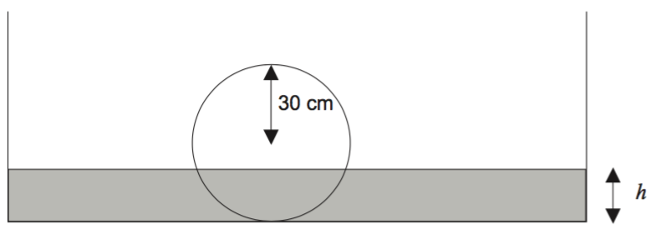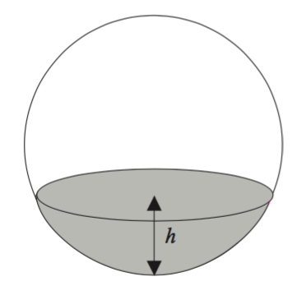
The volume of the submerged portion, where $r$is the radius of the sphere is given by
$$V=\frac{πh^{2}}{3}\left(3r-h\right), 0≤h≤2r$$
Using the small change formula: $δV≈\frac{dV}{dh}δh$ or equivalently $δV≈V^{'}\left(h\right)×δh$

Calculate to 1d.p. the approximate increase in submerged volume for a $0.1cm$ increase in height when $h=15cm$

- [6 marks]
The graph of the function $y=f(x)$ is shown below over the domain $-2≤x≤2$.
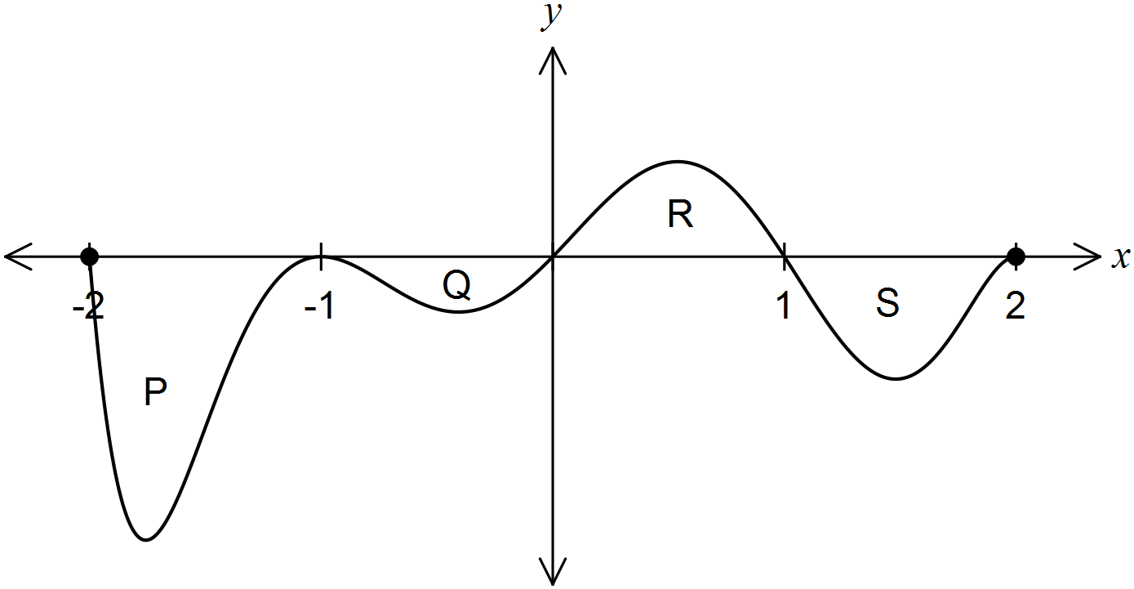

The areas of regions P, Q, R and S enclosed by the curve and the $x-axis$ are 5, 1, 2 and 3 square units respectively.

  - Determine the area enclosed by the curve and the $x-axis$ for $-1≤x≤1$. (1 mark)

  - Determine the value of

- $\int_{-1}^{2}{\begin{matrix} \\ f(x) \\ \end{matrix} dx}$ (1 marks)

- $\int_{0}^{2}{\begin{matrix} \\ f\left(x-1\right) \\ \end{matrix}dx}$ (2 marks)

- $\int_{-1}^{2}{\begin{matrix} \\ 2x+f\left(x\right) \\ \end{matrix} dx}$ (2 marks)

- [7 marks]
A cylinder of radius $r$metres and height $h$ metres is to be constructed inside a cone of height $6 metres$ and base radius $3 metres$ as shown.
r
  - Show clearly why $h = 6 2r$. (1 mark)

h

  - Show clearly why the volume of the cylinder is given as: $V=6πr^{2}-2πr^{3}$ (2 marks)

  - Use Calculus to determine the dimensions (i.e. height & radius) of such a cylinder which gives maximum volume. (4 marks)

- [8 marks]
A particle, initially stationary and at the origin, moves subject to an acceleration, $a$ ms⁻², as shown in the graph below for $0≤t≤20$ seconds.

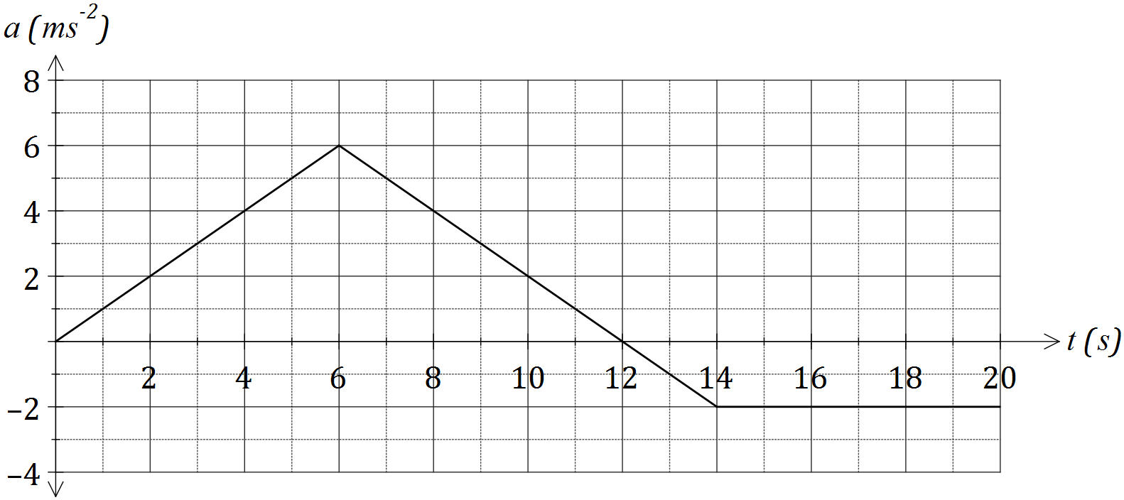

a) Determine the velocity of the object when

- $t=6$. (1 mark)

- $t=20$. (2 marks)

b) At what time is the velocity of the body a maximum, and what is the maximum velocity? (2 marks)

c) Determine the distance of the particle from the origin after $3$ seconds. (3 marks)

- [5 marks]
Leveraging your calculator use the calculus tools of the first and second derivative to determine the location and nature of all the stationary points of
$$y={\left(x-1\right)}^{3}{\left(x-4\right)}^{2}$$

- [5 marks]
Shown are the graphs of
$$f\left(x\right)=\frac{1}{4}\left(x+4\right)\left(x+1\right){\left(x-2\right)}^{2}$$
$$g\left(x\right)=\frac{7}{4}\left(x+1\right)$$

a
b

  - Write an appropriate calculation using three integrals that can be used to determine the area bound by the two curves $y=f(x)$ and $y=g(x)$. Do not evaluate. (3 marks)

  - Calculate the area bound between the curves $y=f(x)$ and $y=g(x)$ by writing and evaluating a single integral over the bounds, $a≤x≤b$. (2 marks)

